Project Design Phase-II
Solution Requirements (Functional & Non-functional)

Date | 30-06-2026
Team ID
Project Name | Rising Water
Maximum Marks | 4 Marks

Functional Requirements:
Following are the functional requirements of the proposed solution.
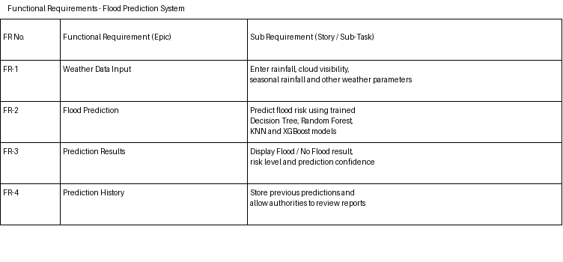

Non-functional Requirements:
Following are the non-functional requirements of the proposed solution.
